Project Id Sheet with Deployment Guide GCD Game Store

# Team Name:

**

# Team Members:

Mitchell Duggan

Jeff Pritchard

Russell Tremain

Qiao Wang(Kevin)

# About GCD Game Store

The GCD Game Store is a way to bridge a digital distribution model with physical distribution. Users of game stores want the convenience of digital distribution for the bulk of their game purchases, but physical editions of games, in particular limited and collectors’ editions can command a sizeable amount of revenue around a game’s launch period. This store will allow users to purchase physical copies which come with a digital copy instantly added to their library to sway users into purchasing these special editions by preserving the convenience of the digital model which dominates the market.

# Quick Start

Open the solution file found in the GCDGameStore folder in Visual Studio 2017. Click on the Run Solution button, with GCDGameStore selected:

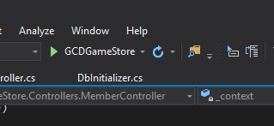

The server will start, build the required database with some initial data seeded, and launch a browser on the home page.

# Deployment Instructions

## How to Create the Database

The server will make sure its database is built when it is run. In its test configuration, the DbInitializer.cs file, found in the Data folder of the project, will ensure deletion and then recreation of the database so that it is in a clean state each launch, at the top of the Initialize method. To switch to a production-friendly mode with a persistent database, remove or comment out the line “context.Database.EnsureDeleted();” found at the top of the “Initialize” method, as shown below:

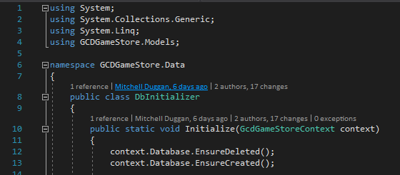

# Waiver

The undersigned permit Conestoga College Information Technology faculty to use the finished application and other deliverables for classroom demonstrations and the marketing of Conestoga College Information Technology programs. Conestoga College Information Technology faculty agree to use the source code only for marking purposes, and not to disclose or distribute the source code to any third party.

Signature: _______________________________ Date: _________________

Signature: _______________________________ Date: _________________

Signature: _______________________________ Date: _________________

Signature: _______________________________ Date: _________________